CHRIS DEUTSCHER MEMORIAL SCHOLARSHIP

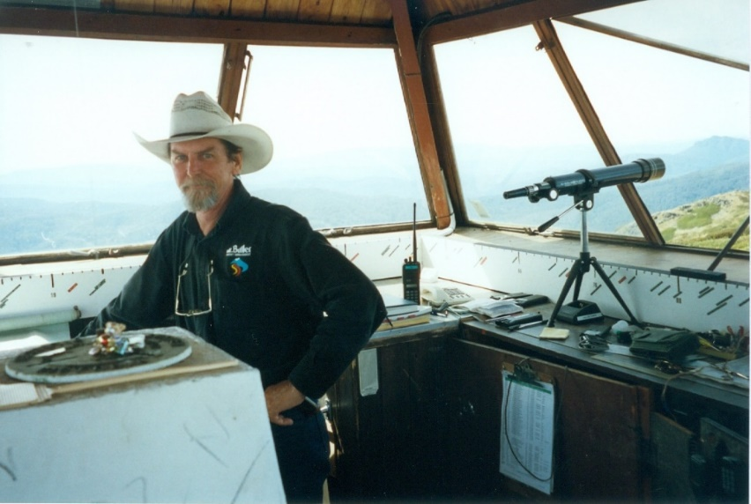
Eagle eyed Chris in his day job as fire spotter at the Mt Buller fire tower.

For the third year, Radio Mansfield 99.7 FM is offering a scholarship in honour of one of our founding members, Chris Deutscher, who passed away in 2018. Chris had a passion for Australian country music and was himself a talented musician.

In his memory, Radio Mansfield has decided to create an annual Memorial Scholarship to promote and encourage two Mansfield students who have a passion and talent for music.

The first grant is by way of encouragement and will be for a primary aged student who has been undertaking music lessons for at least a year. The sum of $300 is for continued music education or towards the purchase/hire of an instrument.

The second grant is for a secondary aged student. The sum of $500 will be awarded in recognition of an achievement in music to date and, again, for the continuance of his/her own music education or towards an instrument or perhaps even to undertake a recording of their own work.

Eligibility Requirements -

Primary Student -
- A consent form completed by your parent/guardian
- Recommendation from your music teacher/school music teacher
- A short piece of writing, telling us a bit about yourself and why you like learning music (approx. 150 words)
- A sample mp3 recording of you playing/singing

Secondary Student –
- A consent form completed by your parent/guardian
- Recommendation from your music teacher/school music teacher
- An essay detailing your music education so far and what you would like to achieve in the future (approx. 300 words)
- A sample mp3 recording of you playing/singing

To enter, firstly, talk to your parents and music teacher.
Then select a piece of music/song which you think best suits your talents.
And, lastly record yourself and enter!

Short listed candidates will be invited to meet and perform their audition piece on Saturday October 14th, 20203 before a panel of judges.

Entries should be forwarded to Radio Mansfield by close of business – 29th September, 2023
Please note, no late entries will be considered.

By email -
scholarship@radiomansfield.org.au

By mail –
Secretary,
Radio Mansfield.
Chris Deutscher Memorial Scholarship
P.O. Box 667
Mansfield 3724

Pease note, the selection panel’s decisions are final, and no further discussion will be entered in to.

We are very pleased to be offering these scholarships and look forward to hearing from you soon.

Attached – Entry form
Parental consent form
Music teacher’s endorsement form

ENTRY FORM

Name ………………………………………………………………………………………………………….

Contact details –

1. Postal address - ……………………………………………………………………………………………………………………………………….
2. Email address –
……………………………………………………………………………………………………………………………………….
3. Phone number/s –
……………………………………………………………………………………………………………………………………..

School ………………………………………………………………………………………………………..

Year Level ………………………………………

Music Teacher …………………………………………………………………………………………..

Vocalist/Instrumentalist …………………………………………………………………………..

Instrument …………………………………….

Song/Music Title ……………………………………………………………………………………….

Composer …………………………………………………………………………………………………

Signed ……………………………………………………………………….. Date…………………………

PARENTAL/GUARDIAN CONSENT FORM

Chris Deutscher memorial scholarship

I, …………………………………………………………………, being the parent/guardian of

……………………………………………………………………. , give permission for her/him to submit an

entry into Radio Mansfield’s scholarship program.

I understand that my daughter/son will meet with and perform their audition piece for the judging panel should she/he be short listed.

Additionally, I understand that all decisions are final.

Signed ……………………………………………………………………………..

Date ………………………………………………………………………………..

MUSIC TEACHER

Chris Deutscher memorial scholarship

I have taught ………………………………………………………………………………………..(name of student)

……………………………………………………………….(instrument/vocals) for …………………….(years).

Name …………………………………………………………………..

Signed …………………………………………………………………

Date ……………………………………………………………………

